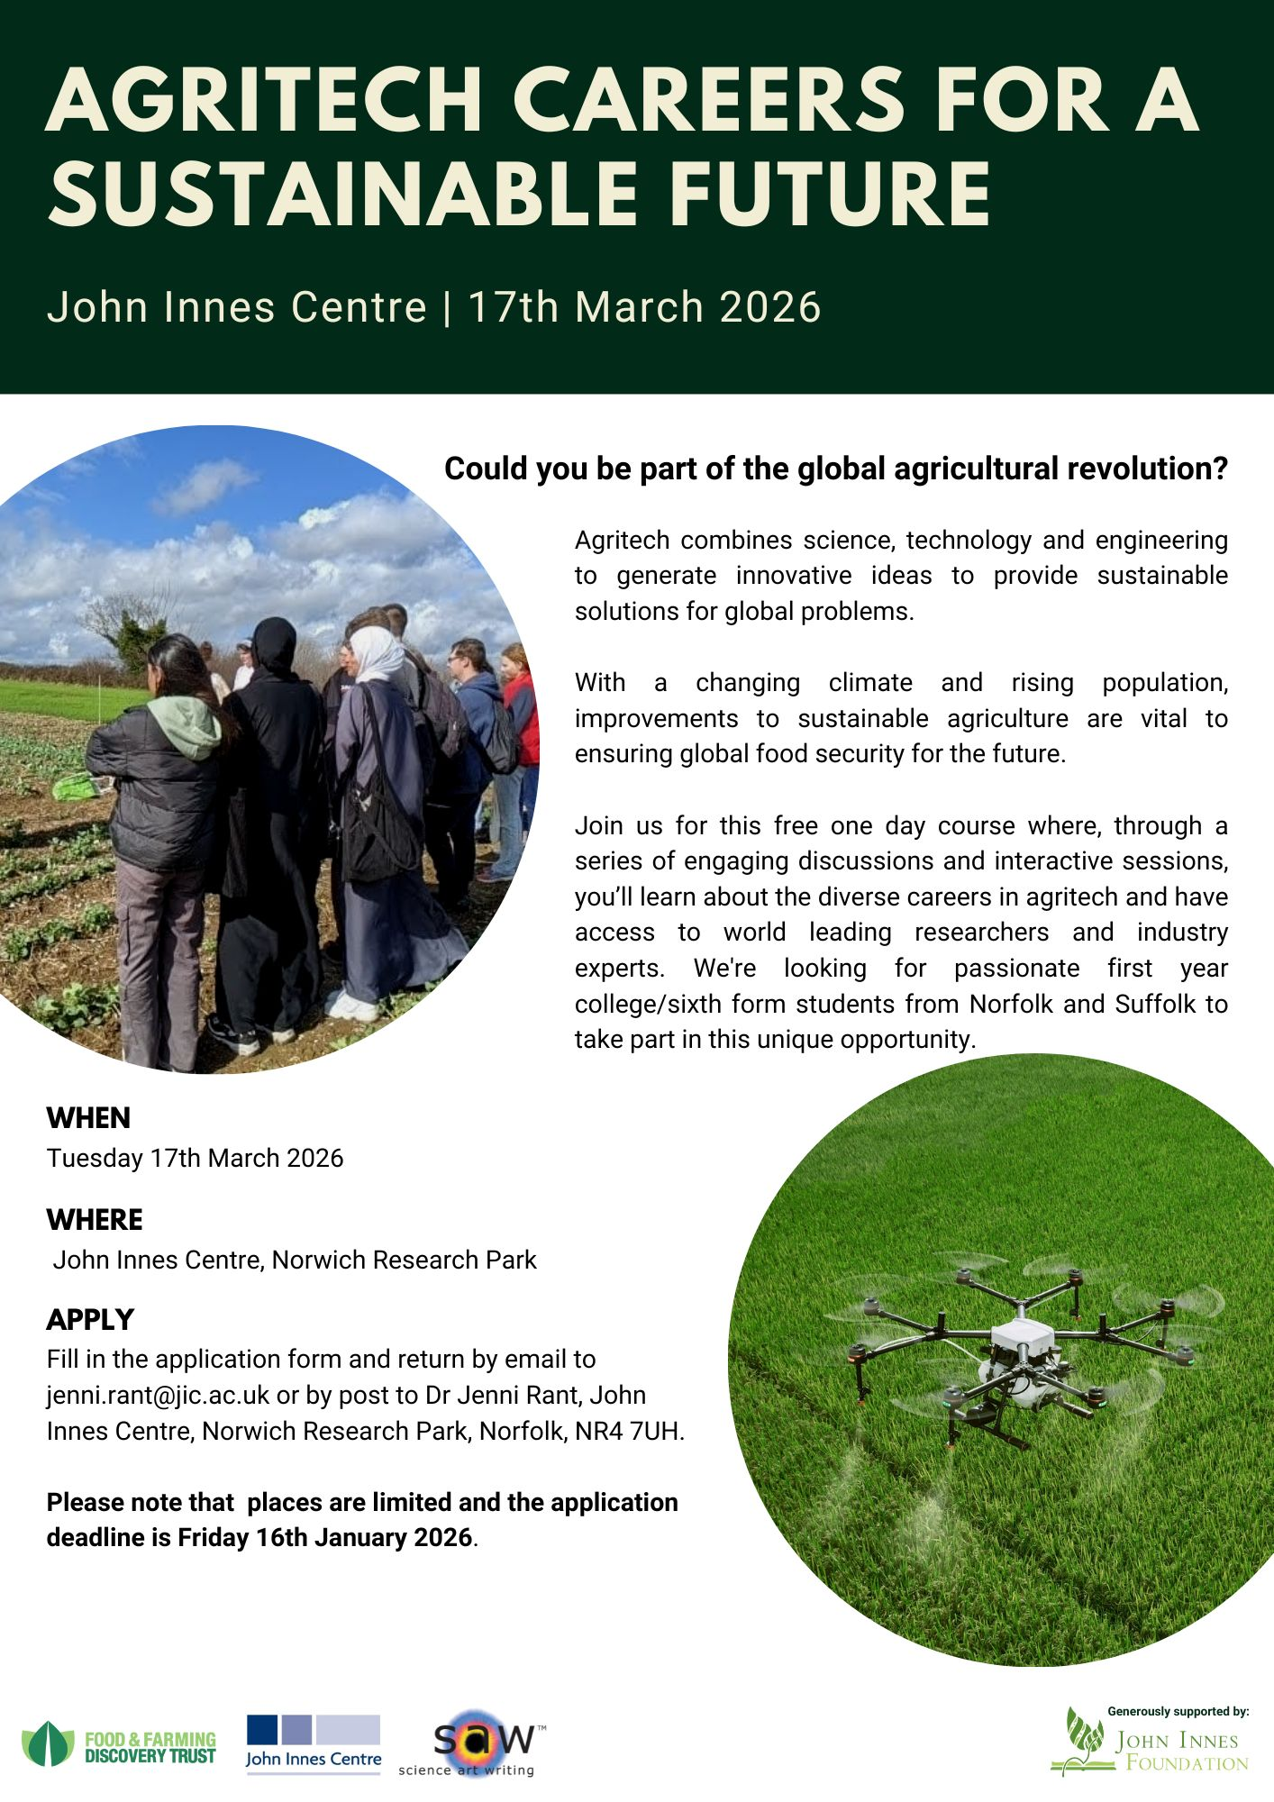

Agritech Careers for a Sustainable Future
Application Form
(Please complete all sections of this form)
The information we collect from you will be for internal use only. We do not collect more information than we need and will not retain it for longer than is necessary. By submitting your response to this form you are giving consent for us to use your data.
Full Name

SCHOOL INFORMATION
School Name
Address
Contact Teacher Name
Contact Teacher Email

AS SUBJECTS
List AS Subjects you are studying

AGRITECH & CAREERS QUESTIONS
- What careers are you interested in pursuing?
- On a scale of 1 to 5, how much do you know about careers in the Agritech sector? | Please circle (1 = nothing, 5 = a lot)  1 2 3 4 5
- Are you considering a career in Agritech – Yes/No & please state why.
PERSONAL STATEMENT
Please write a short statement (no more than 250 words) explaining why you would like to attend and what you hope to get out of the day.

PARENTAL/GUARDIAN CONSENT
If successful, I give permission for to attend the Agritech Careers for a Sustainable Future Event on Tuesday 17th March 2026 from 9.15am – 3.30pm at the Norwich Research Park, Norwich, NR4 7UH.
In case of emergency, I give / do not give* permission for my child to receive medical treatment. *Please tick as applicable.
In case of an emergency please provide contact details for a parent or carer:
Name |  | Contact number
Signature |  | Date

Does the student have any allergies, specific access or dietary requirements?
………………………………………………………………………………………………………………………..
Please note, there is no cost to attend this course. If your application is successful, your named contact teacher will notify you by the 30th January 2026.
Please send completed application forms by email to: jenni.rant@jic.ac.uk or by post to: Dr Jenni Rant, John Innes Centre, Norwich, Norfolk, NR4 7UH.
Deadline for applications is Friday 16th January 2026

